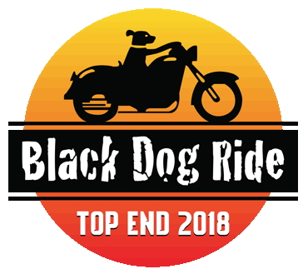
DATE: _____________ RIDE REGION: _____________
REGISTRATION PRICE:
DAY RIDER OR PILLION $145pp
◻ Cash ◻ Cheque ◻ EFT/Square Card

Participant information to support Black Dog Ride’s suicide prevention project planning
These questions are entirely voluntary and confidential. We appreciate your input to help us plan appropriate activities which promote awareness of depression and suicide prevention.
Do you have lived experience with (tick as many as apply to you): ◻ suicide or suicidal ideation
◻ suicide bereavement ◻ caring for someone with a mental illness ◻ living with mental illness
If you answered yes to any of the above, would you be willing to share your story with us? ◻ Yes ◻ No
Would you be interested in learning more about (tick as many as apply): ◻ volunteering with BDR
◻ training in Mental Health First Aid ◻ participating in other local BDR activities ◻ sponsoring BDR

Adult Rider or Pillion Information – Strictly 1 Form Per Person
◻Day Rider ◻Day Pillion ◻Top End Rider ◻Top End Pillion  ◻ Male ◻ Female ◻ Other |  | Start/End Point:
Email Address:
Mobile Number:
Home Address:
The Information Below Is Required to Support You In Case of Emergencies
Your Date of Birth: / / | NOK Name (not your pillion!):
NOK Relationship: | NOK Phone:
Bike Brand, Make & Rego (Plate) Number:
Your Health: (inc prescription medication)
Black Dog Ride Top End 2018 Disclaimer
I, the aforementioned registered participant in Black Dog Ride’s Top End 2018 acknowledge I have read and
accept the attached Terms and Conditions (Disclaimer) for participation in this activity, and acknowledge the risks arising from attending or participating in this activity, and being provided with services in the activity by Black Dog Ride Australia Ltd organisers, by signing below:
Signature: ________________________________________ Date: ________________________________

