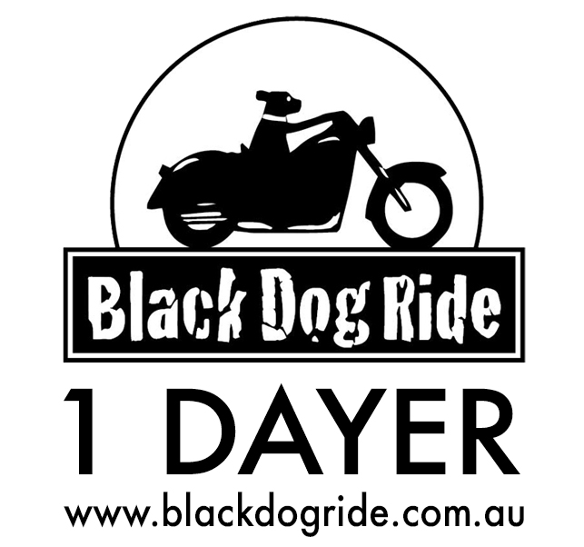
DATE: 18th MARCH 2018

RIDE REGION:

REGISTRATION PRICE:
MC RIDER: $30 and MC PILLION $15

REGISTRATION FORM FOR PERSONS UNDER 18 YEARS OLD
◻ Rider ◻ Pillion | ◻ Male ◻ Female ◻ Other |  | Name:
Email Address:
Mobile Number:
IN CASE OF EMERGENCY – INFORMATION WE NEED TO ASSIST YOU
Your Date of Birth: / / |  | NOK Name (not pillion!):
NOK Relationship: |  | NOK Phone:
Bike Make & Rego (Plate) Number:
Medical Issues:
BLACK DOG RIDE 1 DAYER DISCLAIMER

I, the aforementioned registered participant in Black Dog Ride’s 1 Dayer acknowledge I have read and accept the attached Terms and Conditions (Disclaimer) for participation in this 1 Dayer, and acknowledge the risks arising from attending or participating in this 1 Dayer, and being provided with services in the 1 Dayer by Black Dog Ride Australia Ltd organisers, by signing below:

Signature of Participant: _____________________________ Date: __________________

PARENT/GUARDIAN CONSENT – PERSONS UNDER 18 YEARS OLD

I (full name) ____________________________________________________ of (address) _________________________________________________________________ am the parent/guardian of (full name) _______________________________________________ who is under 18 years old. I have read the disclaimer and understand it’s contents, which include exclusion of liability and assumption of risk, and I have explained the contents to the minor. I consent to this minor participating in the 1 Dayer at his/her own risk.

Signature of Guardian: ______________________________ Date: __________________

